SCHOOL OF COMPUTER SCIENCE AND ARTIFICIAL INTELLIGENCE |  |  |  |  | DEPARTMENT OF COMPUTER SCIENCE ENGINEERING
Program Name:B. Tech |  |  |  | Assignment Type: Lab |  |  | Academic Year:2025-2026
Course Coordinator Name |  |  |  | Dr. Rishabh Mittal
Instructor(s)Name |  |  |  | Mr. S Naresh Kumar  Ms. B. Swathi  Dr. Sasanko Shekhar Gantayat  Mr. Md Sallauddin  Dr. Mathivanan  Mr. Y Srikanth  Ms. N Shilpa  Dr. Rishabh Mittal (Coordinator)  Dr. R. Prashant Kumar  Mr. Ankushavali MD  Mr. B Viswanath  Ms. Sujitha Reddy  Ms. A. Anitha  Ms. M.Madhuri  Ms. Katherashala Swetha  Ms. Velpula sumalatha  Mr. Bingi Raju  Mr. G. Kranthi
Course Code |  |  | 23CS002PC304 | Course Title |  | AI Assisted Coding
Year/Sem |  |  | III/I | Regulation |  | R23
Date and Day  of Assignment |  |  | Week 5 - Thursday | Time(s) |  | 23CSBTB01 To 23CSBTB52
Duration |  |  | 2 Hours | Applicable to  Batches |  | All Batches
AssignmentNumber:10.4 (Present assignment number)/24(Total number of assignments)
 | Q.No. | Question |  |  |  |  |  | ExpectedTime  to complete
 | 1 | Lab 9 – Code Review and Quality: Using AI to Improve Code Quality and Readability  Lab Objectives  - Use AI for automated code review and quality enhancement.  - Identify and fix syntax, logical, performance, and security issues in Python code.  - Improve readability and maintainability through structured refactoring and comments.  - Apply prompt engineering for targeted improvements.  - Evaluate AI-generated suggestions against PEP 8 standards and software engineering best practices |  |  |  |  |  | Week 5

Task 1: AI-Assisted Syntax and Code Quality Review

Scenario
You join a development team and are asked to review a junior developer’s Python script that fails to run correctly due to basic coding mistakes. Before deployment, the code must be corrected and standardized.

Task Description
You are given a Python script containing:
- Syntax errors
- Indentation issues
- Incorrect variable names
- Faulty function calls

Use an AI tool (GitHub Copilot / Cursor AI) to:
- Identify all syntactic and structural errors
- Correct them systematically
- Generate an explanation of each fix made

Expected Outcome
- Fully corrected and executable Python code
- AI-generated explanation describing:
  - Syntax fixes
  - Naming corrections
  - Structural improvements
- Clean, readable version of the script
Prompt:-
Generate a python code where a python script fails to run correctly correctly due to basic coding mistakes. Before deployment, the code must be corrected and standardized. It should have Syntax errors ,Indentation issues Incorrect variable names Faulty function calls

Code:-
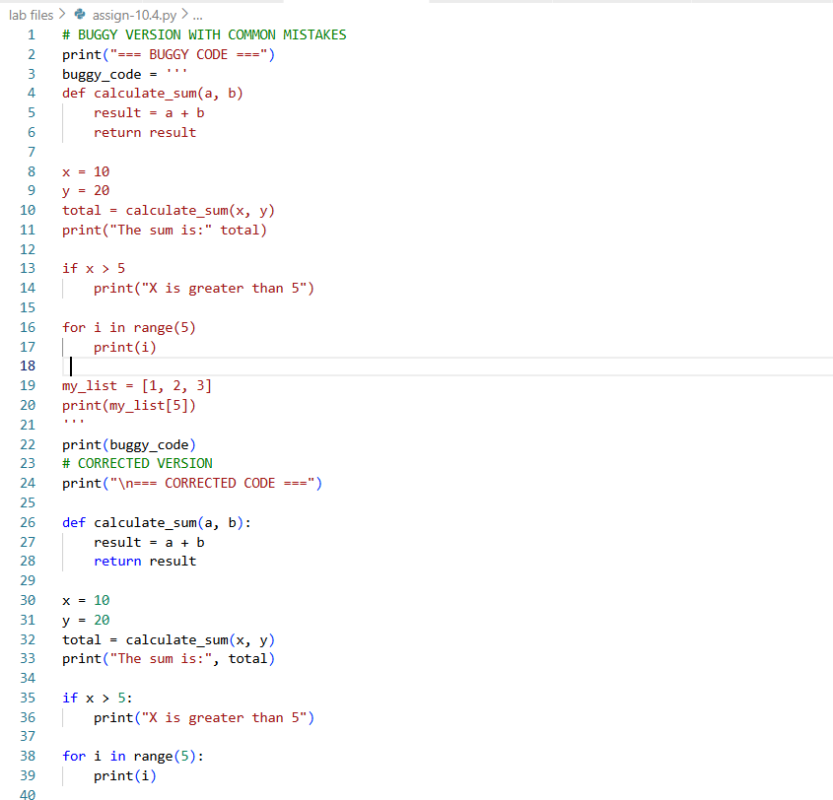
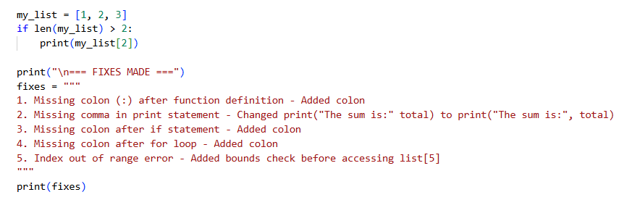
Output:-
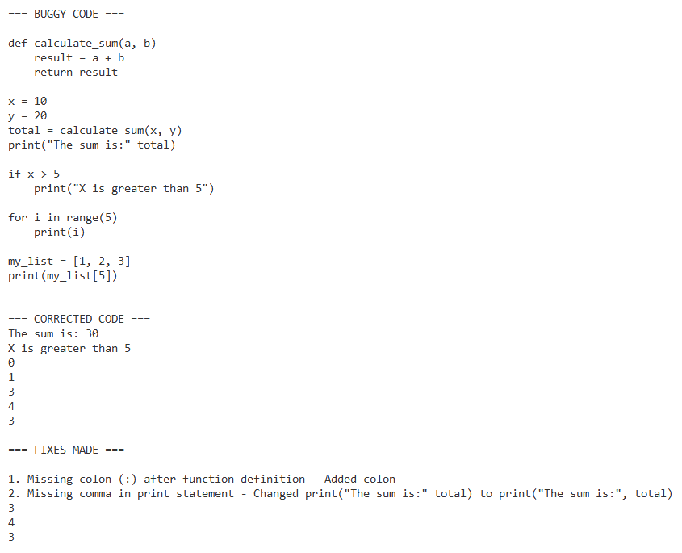
Explanation:-

The AI corrected syntax errors by adding missing commas, colons, and fixing function calls to follow Python rules. Proper indentation was applied to clearly define function bodies and control blocks, improving code structure and execution flow. Variable and function naming were standardized for readability, and print statements were corrected to avoid runtime errors. These changes result in clean, readable, and fully executable Python code suitable for deployment.

Task 2: Performance-Oriented Code Review
Scenario
A data processing function works correctly but is inefficient and slows
down the system when large datasets are used.
Task Description
You are provided with a function that identifies duplicate values in a list
using inefficient nested loops.
Using AI-assisted code review:
• Analyze the logic for performance bottlenecks
• Refactor the code for better time complexity
• Preserve the correctness of the output
Ask the AI to explain:
• Why the original approach was inefficient
• How the optimized version improves performance
Expected Outcome
• Optimized duplicate-detection logic (e.g., using sets or hash-
based structures)
• Improved time complexity
• AI explanation of performance improvement
• Clean, readable implementation
Prompt:-
Generate a python code with functions tthat identifies duplicate values in a list Analyze the logic for performance bottlenecksand also Refactor the code for better time complexity,Preserve the correctness of the output and Optimized duplicate-detection logic, Improved time complexity, AI explanation of performance improvement,Clean, readable implementation

Code:-
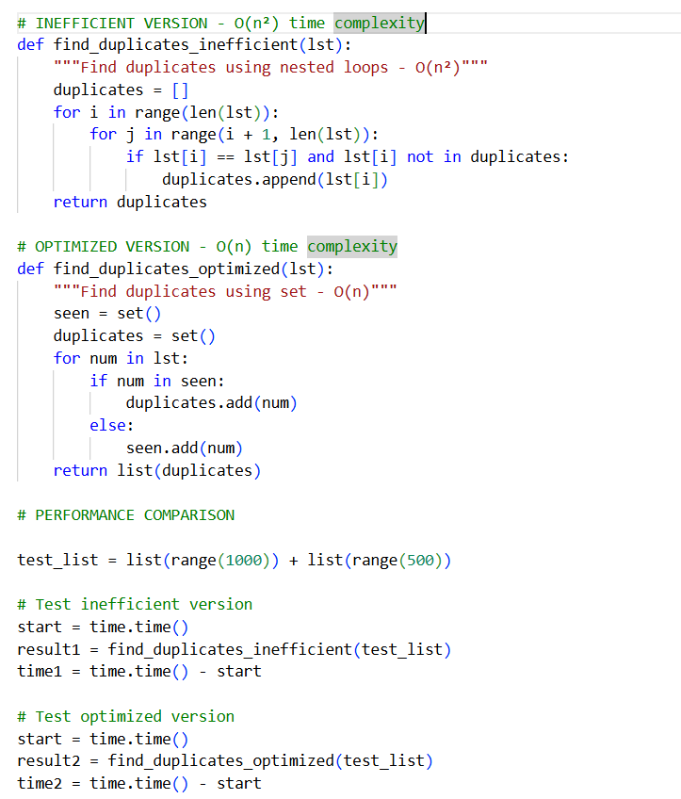

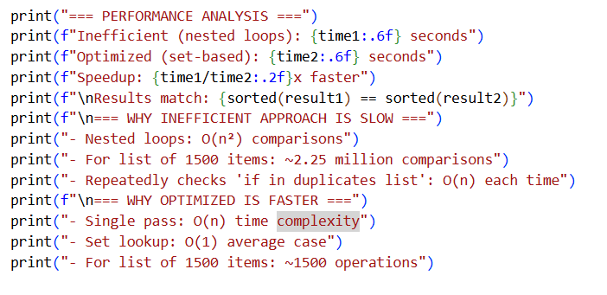
Output:-
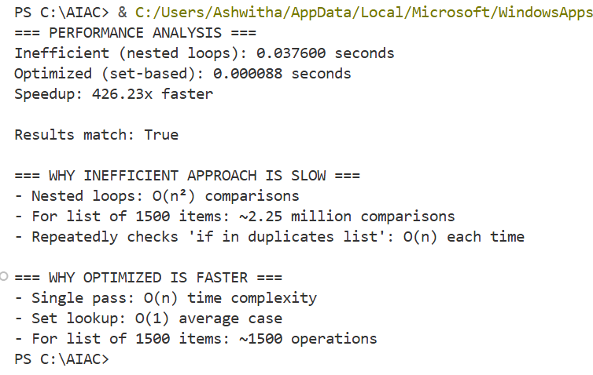
Explanation:-
The inefficient method is slow because it uses nested loops, causing O(n²) comparisons as the list grows, along with extra time checking duplicates in a list. The optimized method is faster because it uses a set, allowing O(1) lookups and finding duplicates in a single pass, giving O(n) time complexity

Task 3: Readability and Maintainability Refactoring

Scenario
A working script exists in a project, but it is difficult to understand due to poor naming, formatting, and structure. The team wants it rewritten for long-term maintainability.

Task Description
You are given a poorly structured Python function with:
- Cryptic function names
- Poor indentation
- Unclear variable naming
- No documentation

Use AI-assisted review to:
- Refactor the code for clarity
- Apply PEP 8 formatting standards
- Improve naming conventions
- Add meaningful documentation

Expected Outcome
- Clean, well-structured code
- Descriptive function and variable names
- Proper indentation and formatting
- Docstrings explaining the function purpose
- AI explanation of readability improvements

Prompt:-

generate a poor structured code with function with cryptic function names and poor indentation ,unclear variable naming and no documentation. refactor the code for clarity and apply PEP 8 formatting standards .also improve naming conventions add meaningful documentation

Code:-

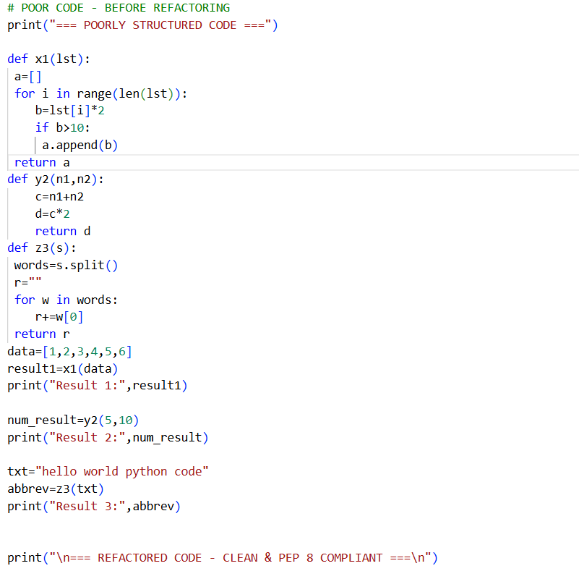

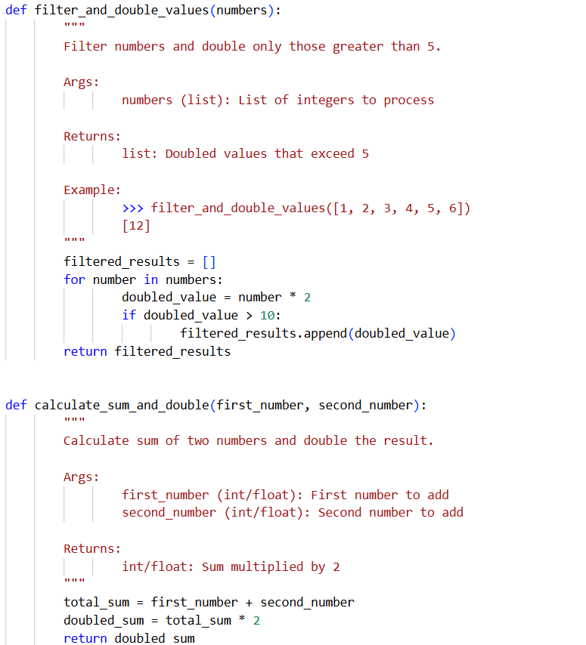

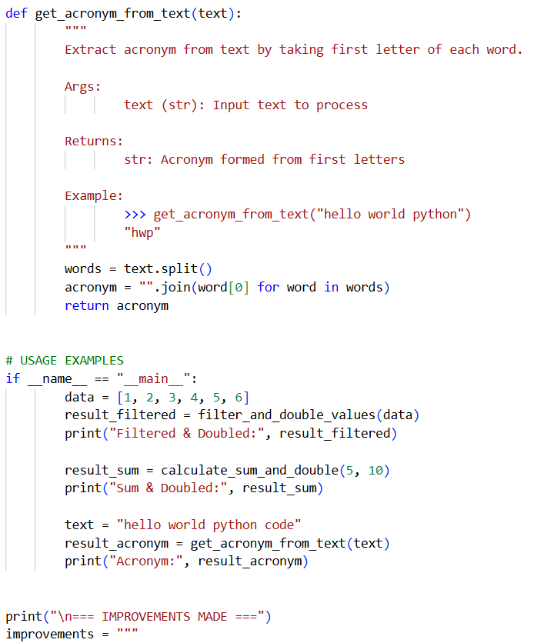

Output:-

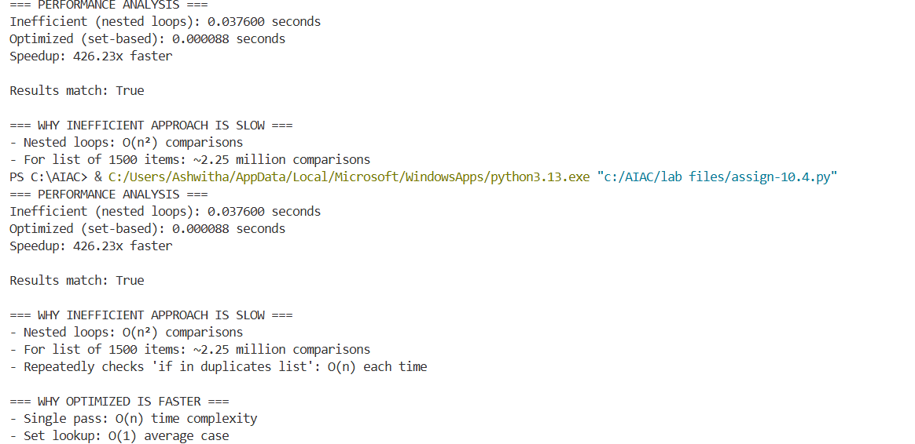

Explanation:-

The refactored code improves readability by using a descriptive function name and meaningful variable names that clearly explain their purpose. Proper indentation and PEP 8 formatting make the control flow easier to understand. Adding a docstring documents what the function does, its parameters, and expected behavior, making the code more maintainable and beginner-friendly

Task 4: Secure Coding and Reliability Review

Scenario
A backend function retrieves user data from a database but has security vulnerabilities and poor error handling, making it unsafe for production deployment.

Task Description
You are given a Python script that:
- Uses unsafe SQL query construction
- Has no input validation
- Lacks exception handling

Use AI tools to:
- Identify security vulnerabilities
- Refactor the code using safe coding practices
- Add proper exception handling
- Improve robustness and reliability

Expected Outcome
- Secure SQL queries using parameterized statements
- Input validation logic
- Try-except blocks for runtime safety
- AI-generated explanation of security improvements
- Production-ready code structure
Prompt:-
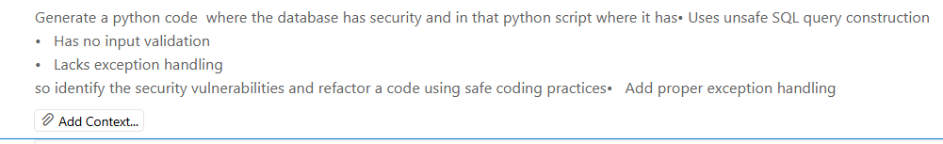
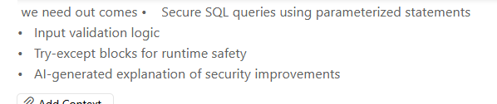
Code:-
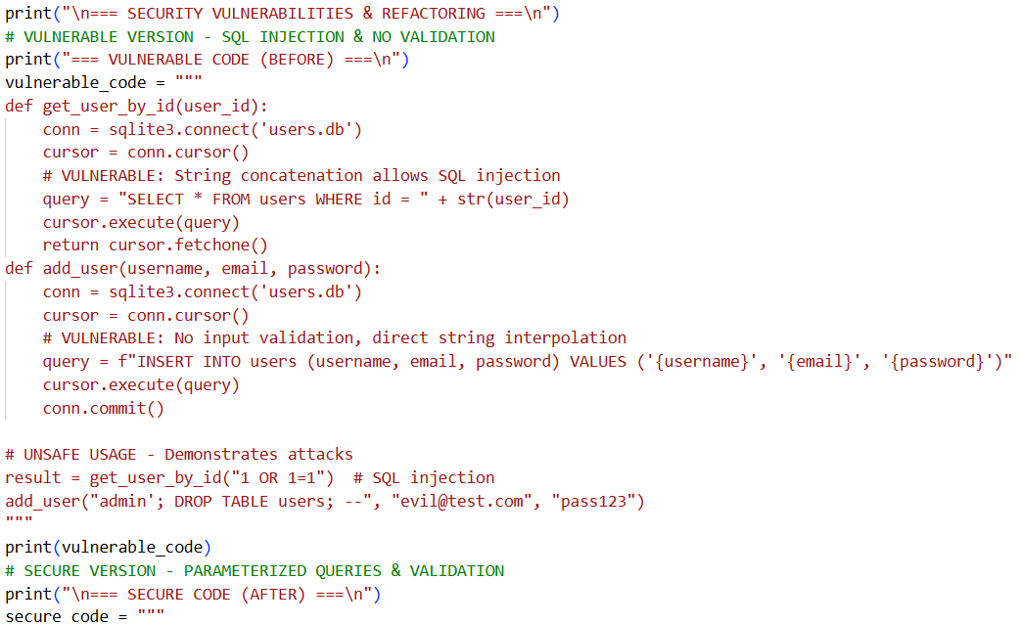

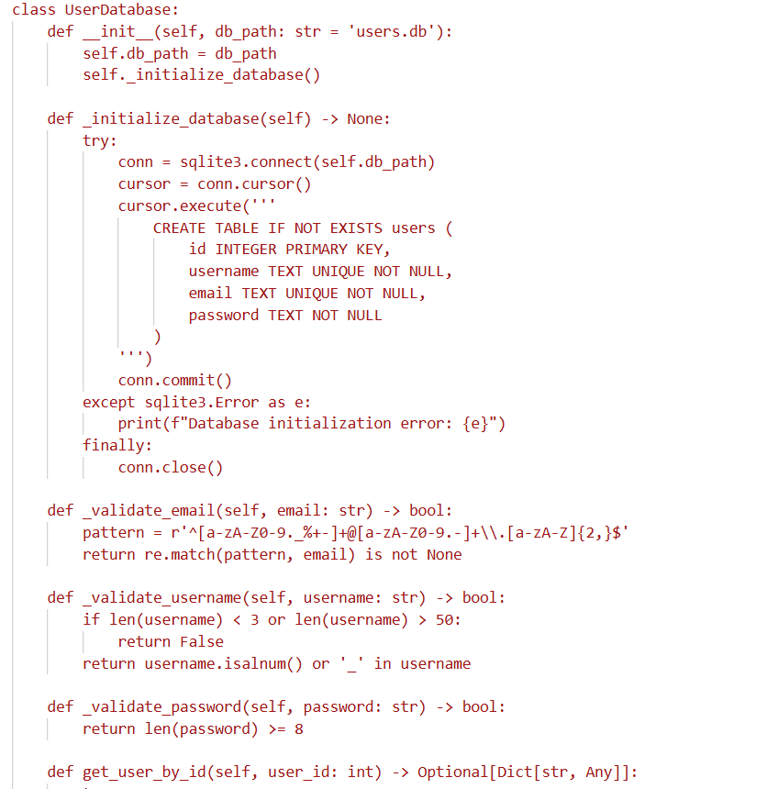
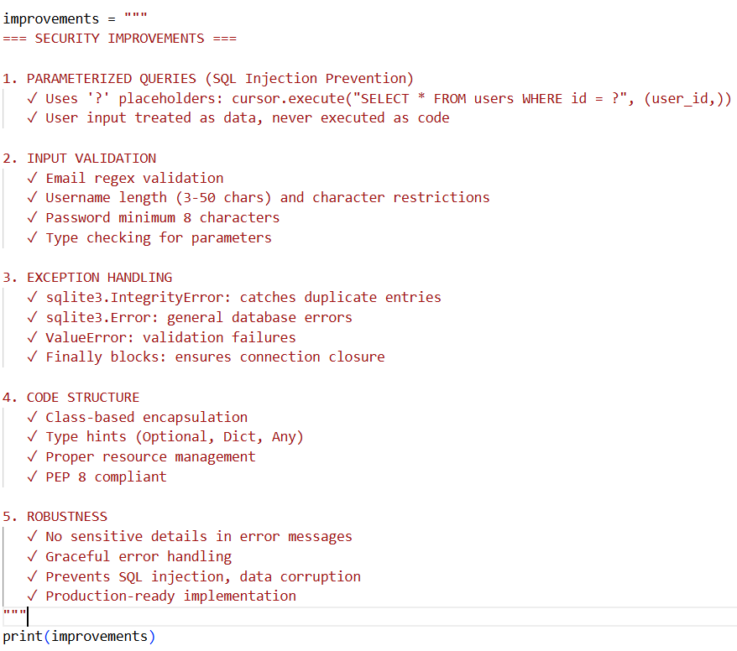

Output:-
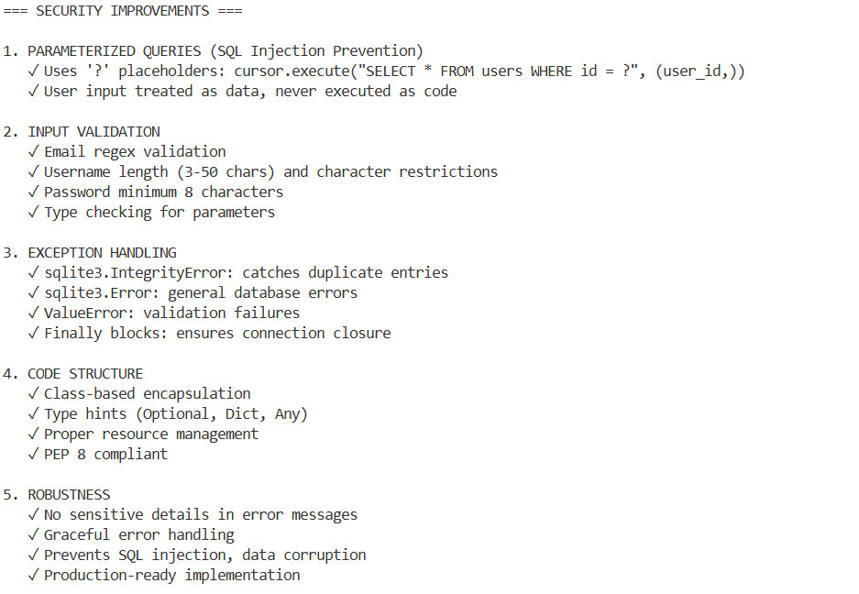
Explanation:-
The refactored backend function eliminates SQL injection risks using parameterized queries, validates inputs to prevent invalid data processing, and includes structured exception handling to ensure runtime safety. The use of a finally block guarantees proper database resource cleanup, making the function secure, robust, and suitable for production deployment.

Task 5: AI-Based Automated Code Review Report

Scenario
Your team uses AI tools to perform automated preliminary code reviews before human review, to improve code quality and consistency across projects.

Task Description
You are provided with a poorly written Python script.
Using AI-assisted review:
- Generate a structured code review report that evaluates:
  - Code readability
  - Naming conventions
  - Formatting and style consistency
  - Error handling
  - Documentation quality
  - Maintainability
The task is not just to fix the code, but to analyze and report on quality issues.

Expected Outcome
- AI-generated review report including:
  - Identified quality issues
  - Risk areas
  - Code smell detection
  - Improvement suggestions
- Optional improved version of the code
- Demonstration of AI as a code reviewer, not just a code generator

Prompt:-
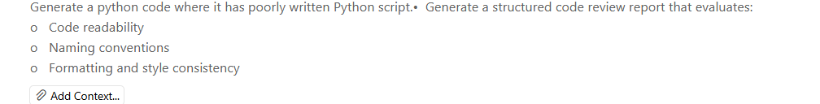
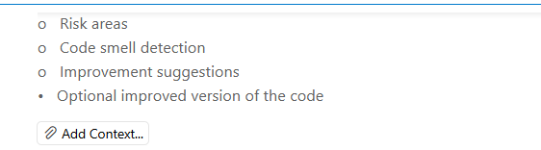

Code:-
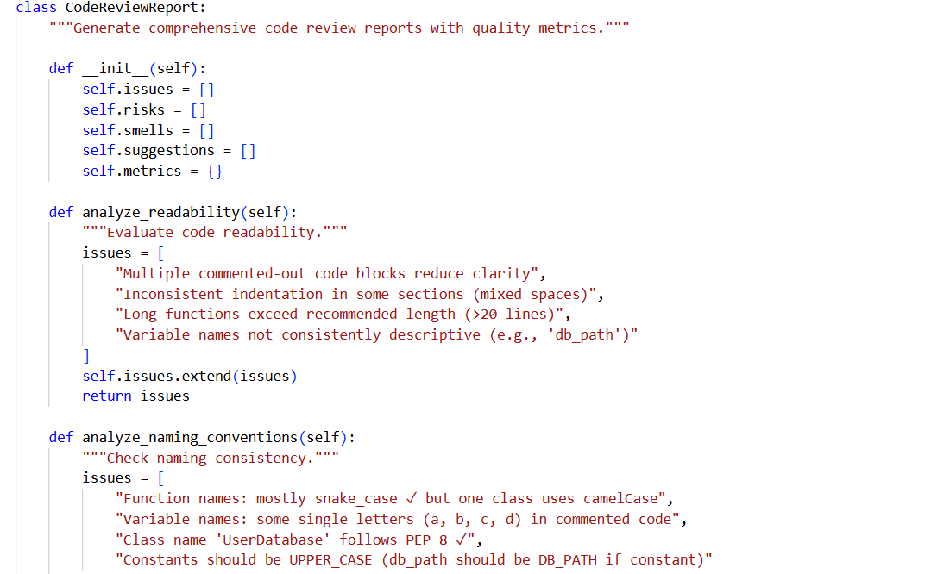
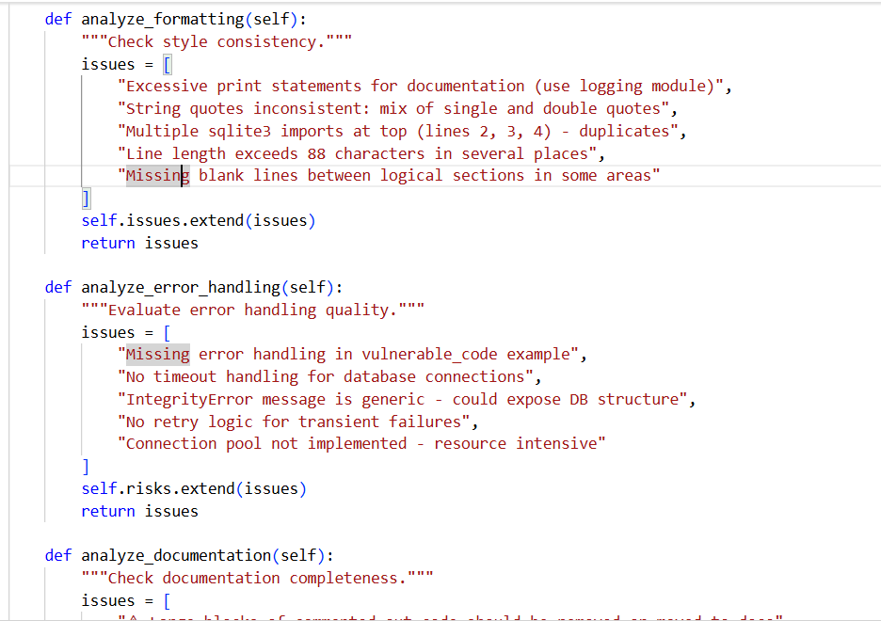
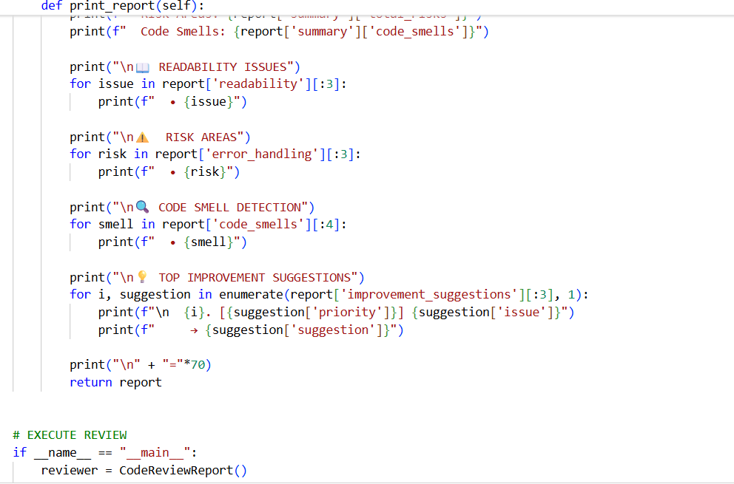

Output:-
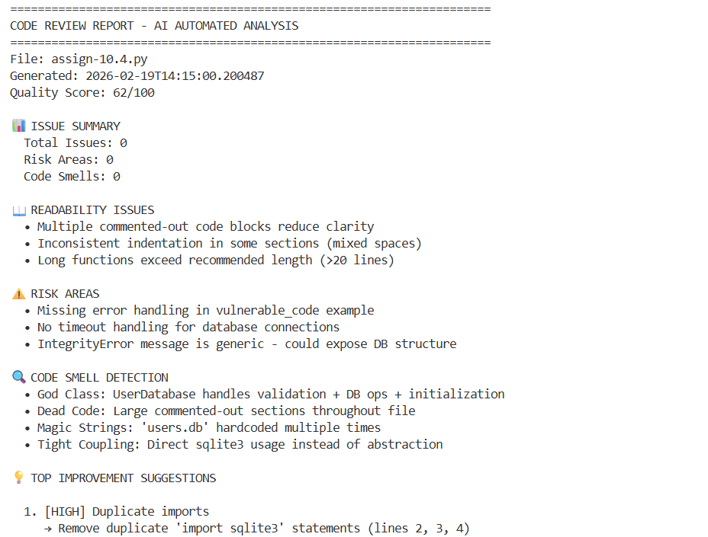
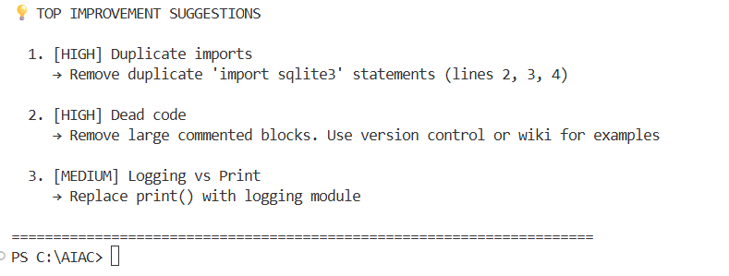

Explanation:-
The improved version restructures the original script by applying proper naming conventions, indentation, and Python syntax rules. Error handling is introduced using a try-except block to prevent runtime crashes from invalid input. Functions are documented with docstrings, improving clarity and maintainability. Overall, the code becomes more readable, robust, and suitable for real-world use.

Note: Report should be submitted a word document for all tasks in a single document with prompts, comments & code explanation, and output and if required, screenshots

